HEADING FOR THE CC NEWSMAIL: FIRE IN FONTAINE, HAITI


st. Gabriel’s school
Fontaine, Haiti

Friends of Fontaine

P.O. Box 11376, Albany, New York 12211
friendsoffontaine@gmail.com ♦ www.friendsoffontaine.com

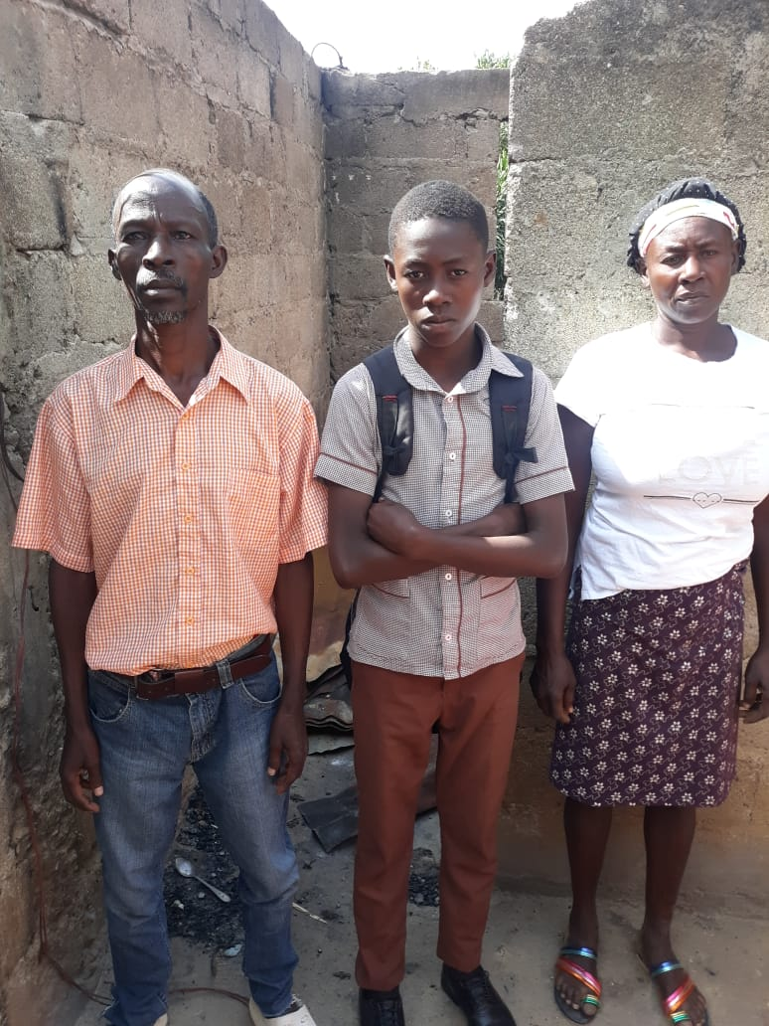

Dear Friends of Fontaine,

We received a note from St. Gabriel’s Executive Director, Audelin Joseph, that a fire in Fontaine destroyed the home of one of our 8th-grade students. I’ve posted Audelin’s note below. If you’d be willing to make a small donation towards helping the family rebuild their home, it would certainly be appreciated. You can send your donation to “Friends of Fontaine”, c/o me (Rev. David E. Noone, 730 Villagio Pl., Apt. 408, Fayetteville, NC 28303). If you prefer
to use a credit card, you can call me, and I’ll be happy to take the information.

Fr. Dave Noone
_____________________________________________

Dear Friends,

It is with a feeling of desolation that I address you and your friends, who share a deep love for our community, which continues to live day by day with sorrows and miseries. Today, I am sad to report that the family of one of our 8th grade students, Chedelin Augustin, were the victims of a serious fire in which their home was completely destroyed. Fortunately, no family members were at home during this tragic and painful event. The family will need $8,846 to rebuild their home. At the moment, the family, which includes Chedelin’s mom, dad, and three siblings, are living with a neighbor who has taken them in temporarily.

So, my dear friends, I’ve attached some photos to give you an idea about this serious incident. If you find friends who are ready to help at whatever level you can, you will, of course, find divine blessing.

Thank you for your understanding and God bless you.

Audelin Joseph

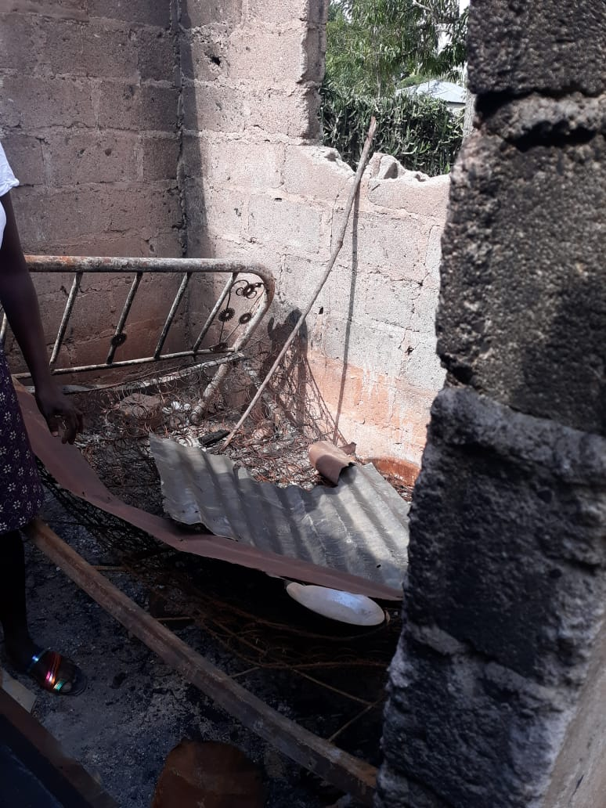
Audelin Joseph.

